**Task 1: Creating a Simple To-Do List**

**Question**: Create a to-do list where users can add tasks, delete tasks, and mark tasks as completed using DOM manipulation.

**Requirements**:

* Create an input field to enter tasks.
* Add a button to add the task to a list.
* Each task should have a delete button.
* Each task should toggle between "completed" and "incomplete" on click.

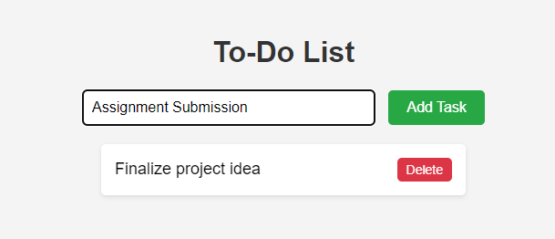

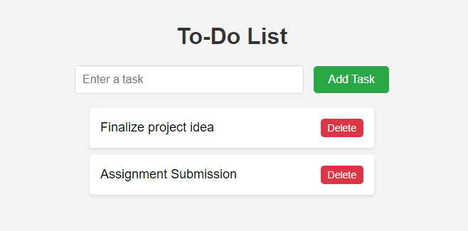

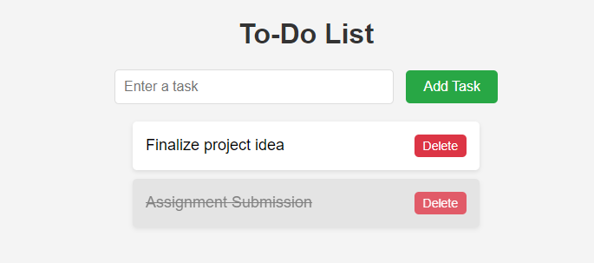

**Toggled to**

**Task 2: Dynamic Image Gallery**

**Question**: Create an image gallery that allows users to add and remove images dynamically using DOM manipulation.

**Requirements**:

* Create an input field to add image URLs.
* A button to add images to the gallery.
* Each image should have a remove button.



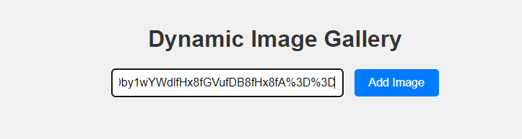

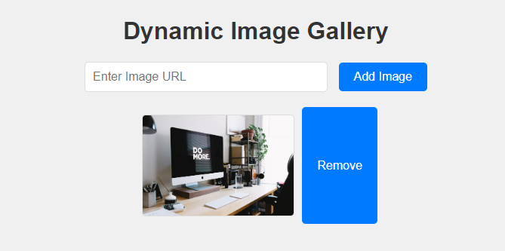

**3. Task 3: Interactive Quiz**

**Question**: Create a simple quiz that allows users to answer questions, and on submission, the score is calculated and displayed.

**Requirements**:

* Create a list of multiple-choice questions.
* Each question should have 4 options.
* After submission, display the score.

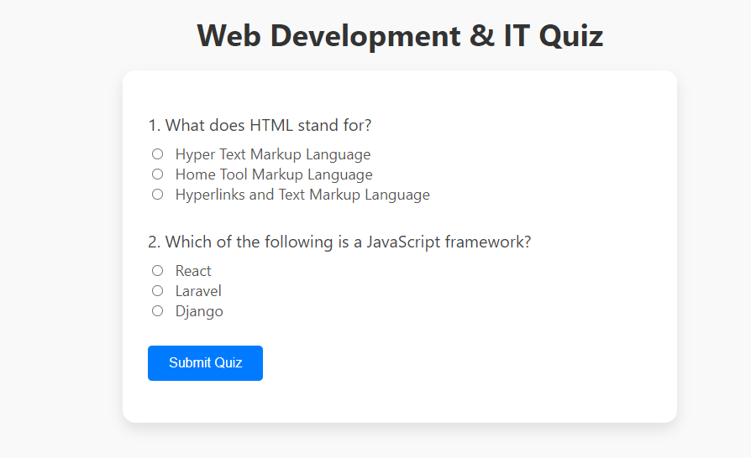

**After Submission (If Fail the quiz display result with Red color)**

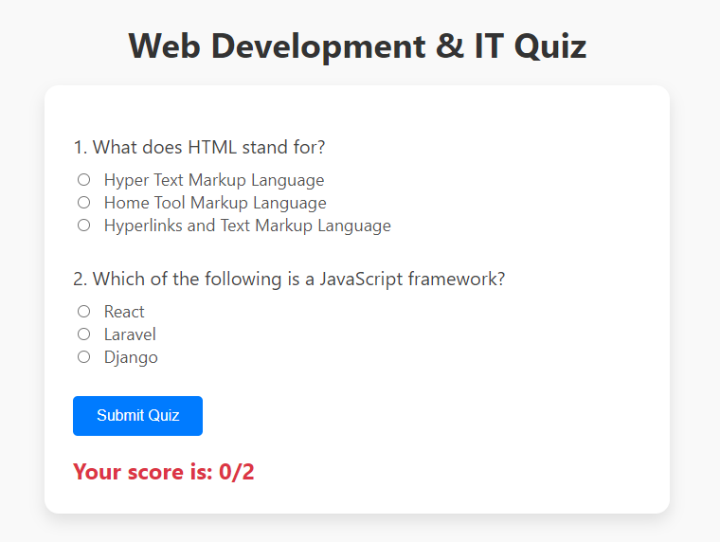

**(If Pass the quiz display result with Green color)**

### ****Task 4: Counter Application****

**Question**: Create a counter that can increment, decrement, and reset the count.

**Requirements**:

• A display area to show the current count (initially set to 0).

• Three buttons:

* **Increment**: Increases the count by 1.
* **Decrement**: Decreases the count by 1.
* **Reset**: Resets the count back to 0.

**INITIALLY SET TO 0**  **INCREMENTED**

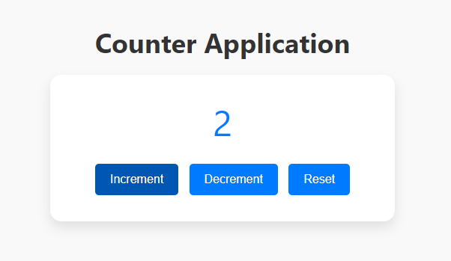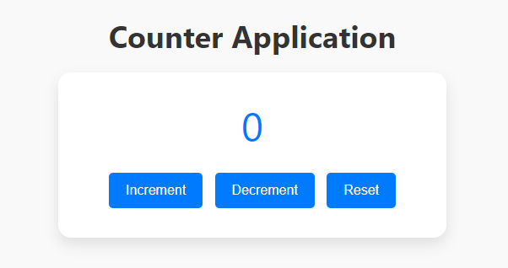

**DECREMENTED**  **RESETS**

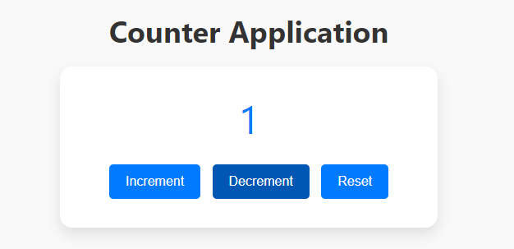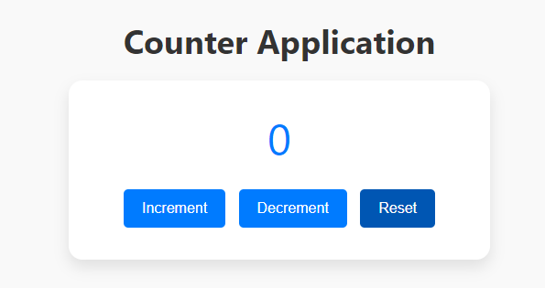

**TASK & SUBMISSION GUIDELINES:**

1. For each task, you are required to create 3 files: Styles(i).css, Script(i).js, and Task(i).html (replace **(i)** with the task number).
2. Create a single folder that contains all the tasks, and compress it into a zip or rar file. Submit the compressed file on GCR only.
3. Name the zip file as Name_RollNo_SE-Section_LabTask.